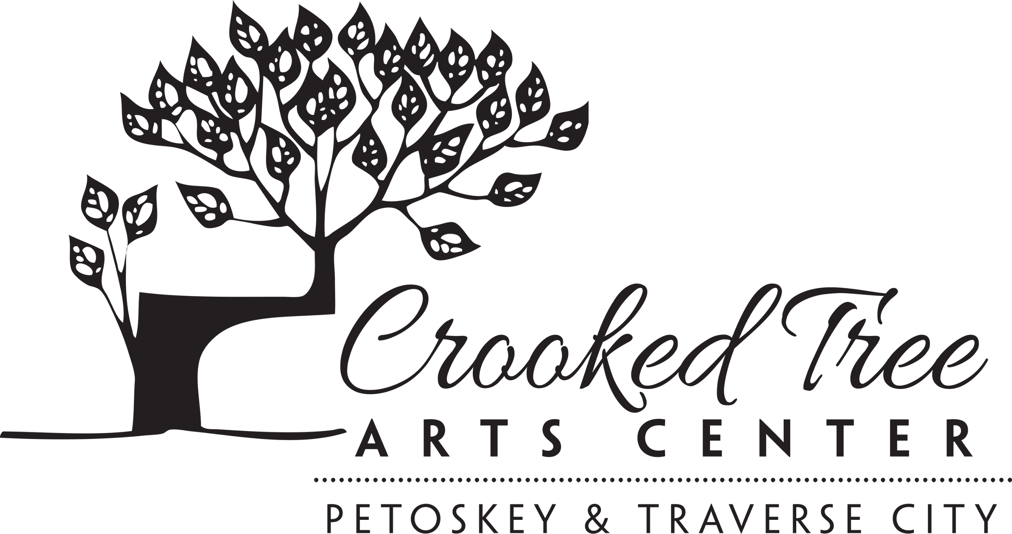
Materials List
Instructor: Alan Larkin
Class/Workshop: Drawing Bootcamp
3 day workshop
May 19-21, 2023
9:30 am - 4:30 pm
One hour break for lunch*
_____________________________________________________________
The beginning set of exercises use a specific set of tools, compressed charcoal, rough newsprint and white plastic erasers. Since later exercises can result in more finished works that can often be very fine I also suggest buying some charcoal or pastel paper.

Prang Compressed charcoal pencils: two medium, one soft
Staedtler Mars plastic eraser
Staedtler Mars plastic eraser pencil
Rough newsprint, 18” x 24”
White charcoal or pastel paper, 4 sheets, 18” x 24”

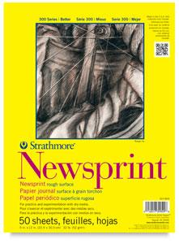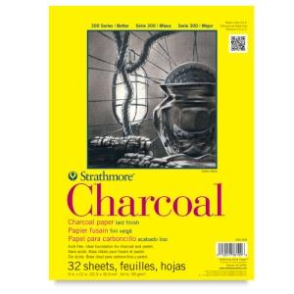
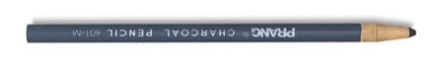
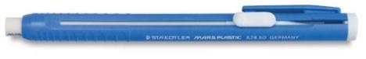
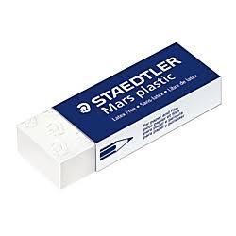

*Lunch: We do not encourage students to leave CTAC to have a sit down lunch in Traverse City as it is unlikely you will have enough time. We will have a list of local restaurants that you can order ahead and pick up lunch or feel free to use our kitchen to keep lunch cold in our refrigerator or warm up food in our microwave.

