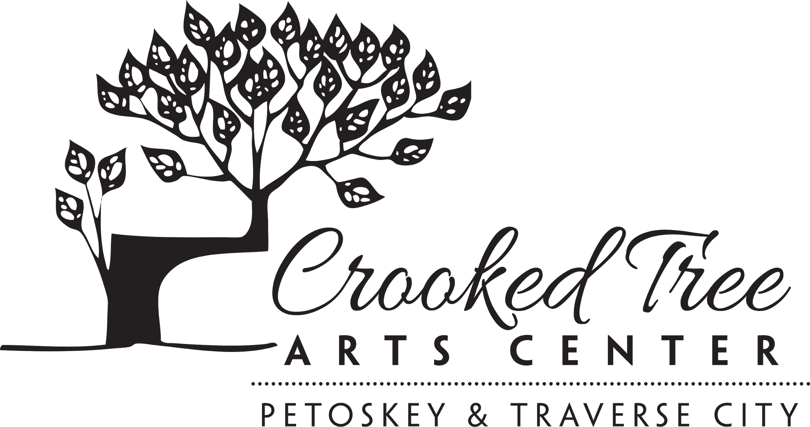
Materials List
Instructor: Steve Griggs, Paint Grand Traverse Artist
Day/Time: Monday & Tuesday, 9:30 am - 4:30 pm
August 17 & 18
Create Moving and Evocative Watercolors!
_____________________________________________________________

Paint

Cadmium or Quinacridone Red
Cadmium or Aureolin Yellow
Ultramarine or Cobalt Blue
Payne’s Grey or Neutral Tint or Sepia

Recommended: M. Graham or Daniel Smith
Acceptable: Van Gogh or Winsor and Newton Cotman Student Grade

Paper

Arches 140 lb – 22” x 30” sheet (2-3 sheets) or 11” x 14” tablet
16” x 20” board to mount paper on
Blue painter’s tape ¾” or 1” wide

Brushes

Princeton Neptune #10 and/or #12 Round Synthetic Squirrel or Hobby Lobby Masters Touch is a good low cost option

Sketchbook

Canson XL Watercolor

Miscellaneous

Sponges, towel, tissues, water container, pencil, small spray bottle, palette
Please bring an abundant sense of humor!

