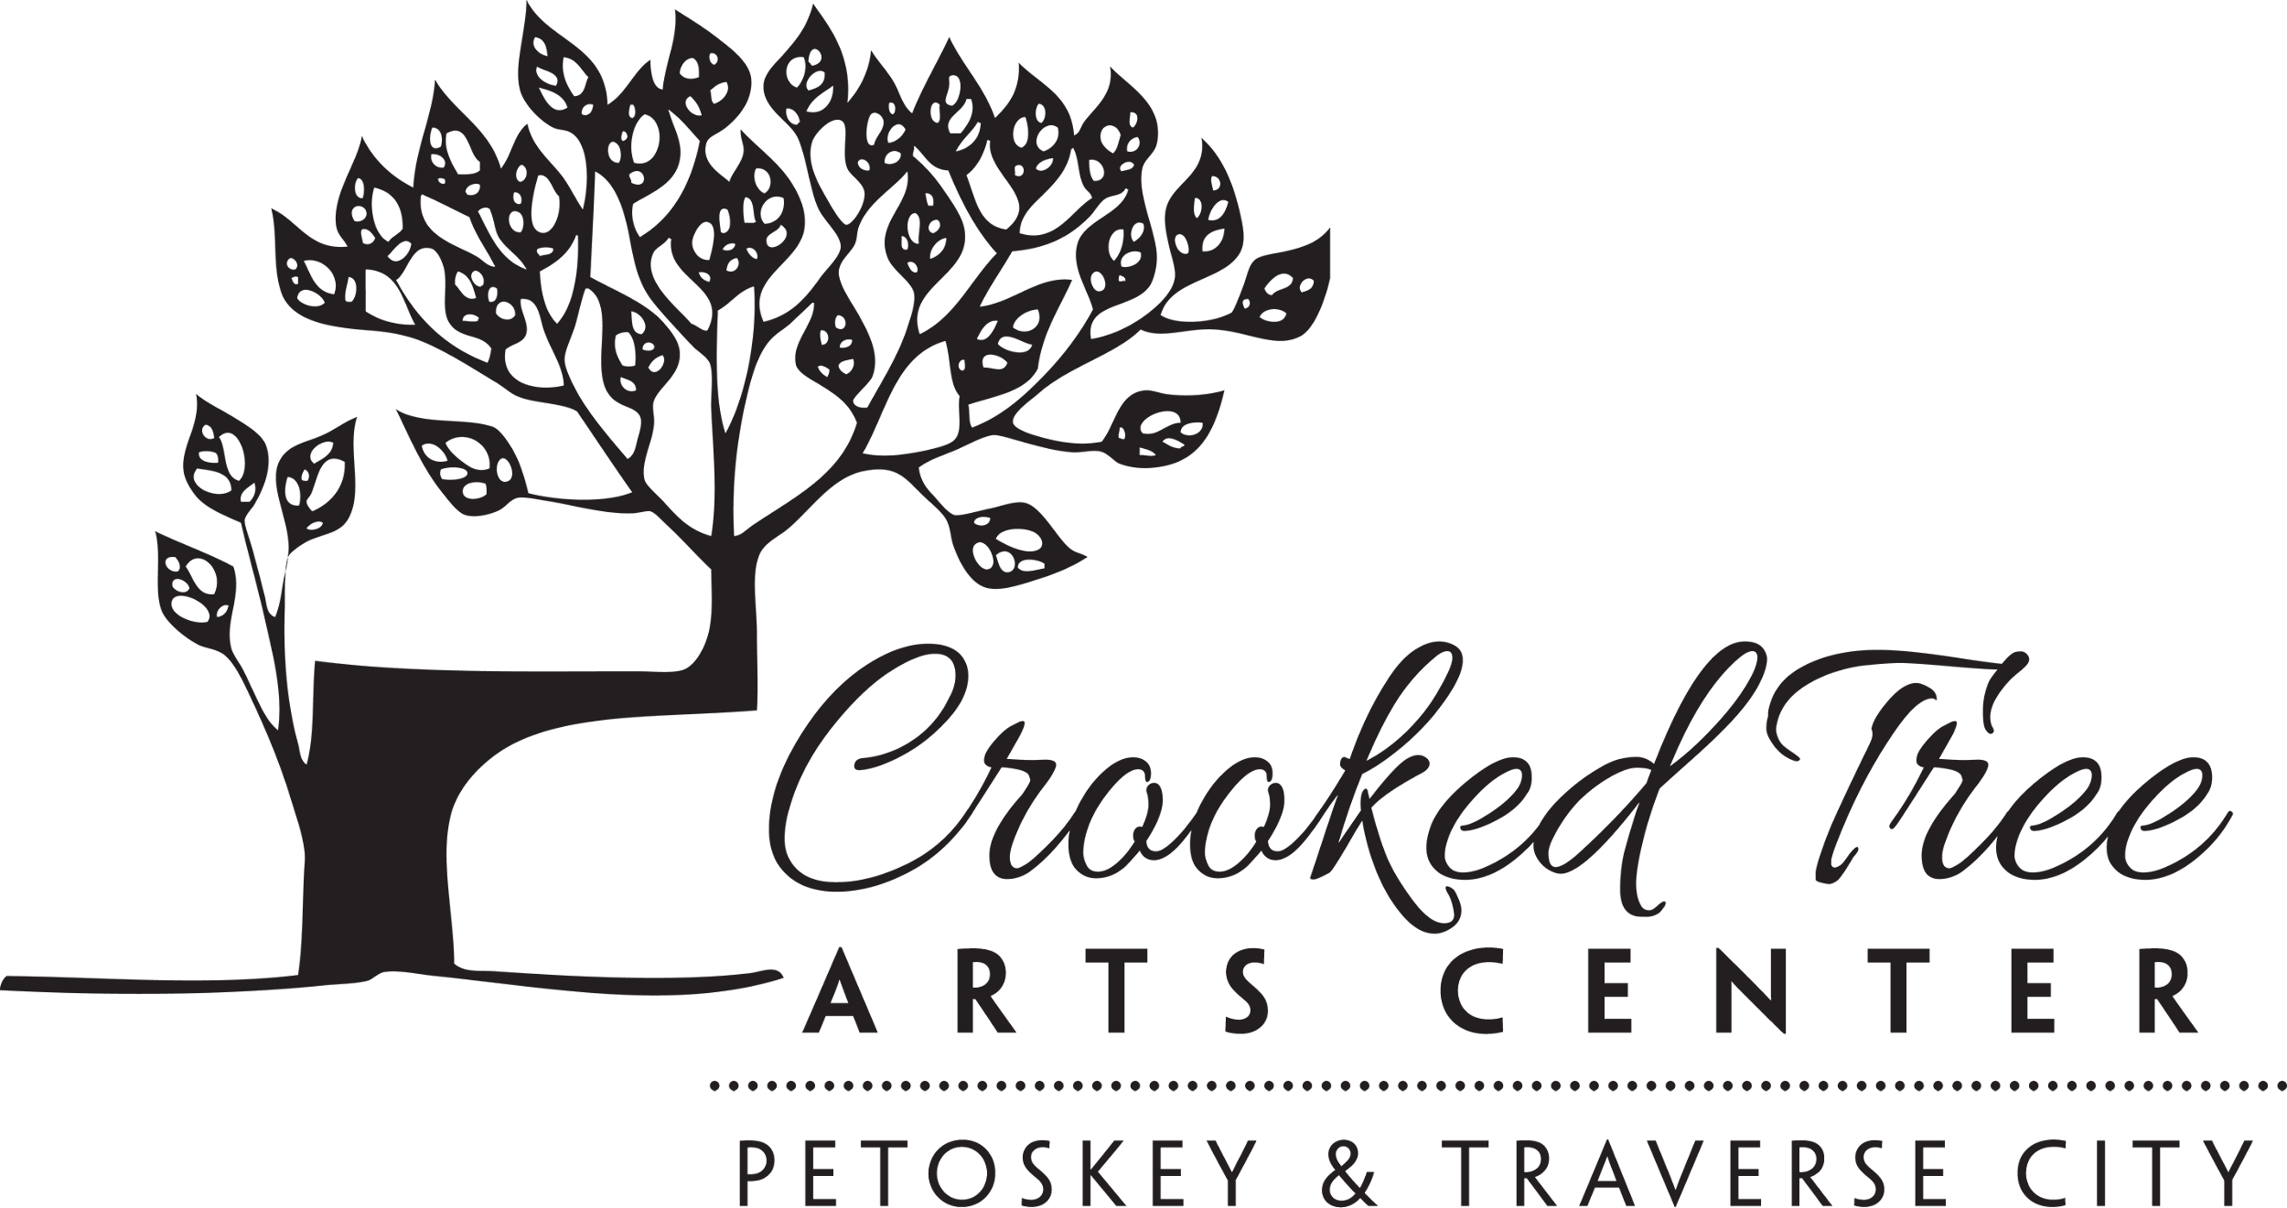
Materials List
Instructor: Valerie Allen
Class/Workshop: The Process Project: Exploration in Abstraction
2 Day Workshop
August 3-4, 2023
9:30 am - 4:30 pm
_____________________________________________________________
SUPPLY LIST
- Pencil (I use an Ebony Design pencil for planning)
- 4-12”x12” canvas panels—not stretched canvas but hard panels.
- Ballpoint or felt tip pen for notes
- Notebook or sketchbook for notes during the class
- Scissors (use economy grade as we may be cutting materials that can dull the scissors)
- 3-disposable 1” foam brush
- 5 to 10 sheets of ordinary gift-wrapping white tissue
- 3 Notebook Sheet Protectors
- Palette knife
- Paint Brushes, bring a few of your favorite nylon or synthetic acrylic brushes. (Not natural fibers) I like to have about a ½”, 1” and 2” width on my brushes.
- Old credit card or hotel plastic key
- A collection of collage materials such as thin packaging, sheet music, newspapers, ephemera. Keep materials thin.
- Blue painter’s tape or frog tape
- Paper Towels
- Spray bottle
- Water Container-medium size
- Apron or paint shirt
- Plastic to put in your car to transport wet paintings home
- A paper bag that can be set up as a trash container at your workstation.

Contact instructor Valerie Allen at valerieallen@outlook.com with any questions.

